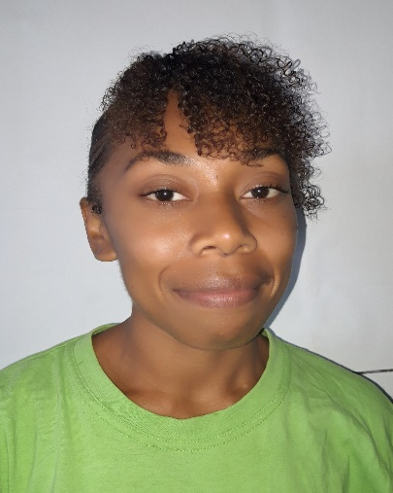  Profile  Name: Taswel  Surname: May  D.O.B: 17/05/1997  Sex: Female  Origin: Banks Island, Vanuatu  Contact  PHONE:  +6785472831  +6787103412  WEBSITE:  EMAIL:  taswelmay@gmail.com  Hobbies  Reading books  Watching movies  Listening to music | Goals: to gain new skills, experience and move to a higher level | Goals: To work in an environment that encourages me to succeed and to do research professionally where I can use my skills and knowledge APPROPRIATELY, EXPERIENCE and move to a higher level.  Objective: A Smart and hardworking individual who is willing to learn from both, NGO and Government to improve my skills. I have gone through many experiences that made me more interests to work. Always in collaborate with colleagues and professional manner. Able to work in team and excellent communication skills. Willing to learn new thing.  WORK EXPERIENCE  Oxfam -Intern Finance Officer.  (Dates From 14 September 2021 to 31 January 2022)  - Prepares Payment Vouchers Oxfam Program related payments  - Liaise with program staff to ensure all required Finance and logistics policy and Procedures are followed  - Maintains a register to track Payments to Oxfam beneficiaries and suppliers  - Prepare and register Cheques and making payment  - Sends remittance advices to beneficiaries and suppliers after payments are made  - Assist in carry out Oxfam office banking  - Assist in international telegraphic transfers payments & cash Deposits  - Carry out appropriate filing of all payment Vouchers & receipts of payments  Oxfam Vanuatu Cash Transfer Program working as call Centre Urgent.  (Dates from October 2020 to August 2021)  - Customer Service  - Communicate with non-beneficiaries, beneficiaries, vendors and implementing partners on communities inside the 3 provinces of Vanuatu. Sanma, Shefa and Tafea.  - Received calls and face to face queries and managing on complaints and feedbacks from Non beneficiaries, beneficiaries, Vendors, Implementing Partners, Staffs and volunteers  - Managed all complaints from serious, major, minor and positive or highlights  - Answering queries for client by hot-line and face to face  - Documentations of the calls and feedbacks mechanisms from calls received.  - All complaints are being managed and refer to technical advisers and respective managers accordingly.  - Do live dashboard monitoring for tracking information’s on the calls received.  - Travelling to Tanna to assist VBRC on vendor registration  - Do Need assessment at offshore island (Mosso, Pele, Nguna, Lelepa, Emau.)  - Follow partners to make awareness and assist on beneficiary Registration  - Do Baseline survey  - Do Vendor and Beneficiary Post Distribution Monitoring survey (PDM)  - Prepare vendor’s phone  - Assist in Send out Bulk SMS from CSV exporting files and original code numbers.  - Do weekly Report  Public service commission [ Data entry officer]  Dates from 4 February 2020 to 2 March 2020  Data entry for electoral office under ministry of internal affairs  Public service commission [intern at VIPAM]  Dates from 17 to 21 June 2019 induction at VIPAM.  Dates from 24 June to 09 August 2019 intern at VIPAM  Enter personal data of government officers, make suggestions, assist in the deployment of Vanuatu government succession planning and further collect personal information of all civil servants in the public sector.  Public service commission [apprentices]  Dates from 14 November to 18 November  Statutory high school level training  Dates from 21 to 25 November 2016  Discovery of the Newcomer Integration System  course & Training  - Oxfam Vanuatu, (Port Vila) -The cash learning Partnership (CALP).  - Safeguarding Essential & safeguarding in Oxfam certificate  - Cash and Voucher Assistance – the fundamentals certificate.  Education  AGENCE UNIVERSITAIRE DE LA FRANCOPHONIE(AUF)  Date institution Level of qualification  2017 - 2019 AUF Bachelor degree  Lycée Antoine Louis de Bougainville (year 14)  Date institution Level of qualification  2016 Lycée LAB Diplomat  2016 Lycée LAB Brevet informatique et internet (b2i)  l  College de luganville (year 10-13)  Date institution Level of qualification  2015 CDL Year 13 certificate  2014 CDL Year 12 certificate  2012 CDL Year 10 certificate  SKILLS
1.Honesty, Loyal, hardworking and willing to learn
2.Able to lead and work as a member of a team and without supervision.
3.Communication Skills
4.Able to use Microsoft word, excel, power point and editor.
5.Able to keep confidential information intimate.
6. Ready to assume my responsibilities with as many precautions and
concentration in order to achieve quality results.
Reference

James Melteres – “VIPAM”
Manager
vipam@vanuatu.gov.vu
5333260

Solomon Vire – Oxfam
Senior Finance officer
solomonv@oxfam.org.au
7341058

