CURRICULLUM VITAE

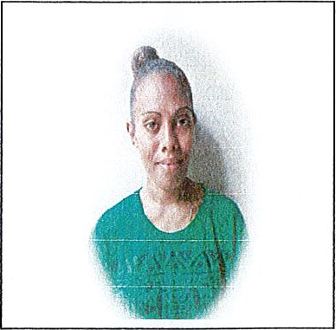
PERSONAL DETAIL
Driver license: NO
HAKWA CLEORINETH Gender: Female
Date of Birth: 12 April 1997
Status: Defector Kid: 1 Boy (9 months)
Island: Ambae
Religion: Presbyterian
Address: Namburu
Language Spoken: English/ Basic French Mobile: (678) 56 21 907 / 73 47 298
EDUCATION
School | Qualification | Years
Santo East School | Year 13 Leaving Certificate | 2018
Epi High School | Year 12 Leaving Certificate | 2017
Tebakor College | Year 10 Leaving Cenificate | 2015
Rensarie College | Year 8 Leaving Certificate | 2013
TRAININGS
Institutions | Skills / ACHIVEMENT | PERIODES
Nat Secretariat Services | Certificate of Secretary and management  Customer service  • Bank monitoring  Salary slept | ()4^{d1} October — 22nd October  2021
SKILLS
Good communication Skills Good Customer Service Skills
Administration Skills
File Management Skills Computing skills
HOBBIES & INTEREST: Reading, listen music, learning new things

