**Curriculum vitae**

**Roger Daniel**

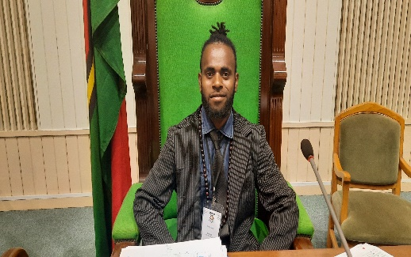

Name & Surname: Roger Daniel

Address : Bladenear estate Port Vila

Tel : 7672364/5242585

Email address : [rogerdaniel311@gmail.com](mailto:rogerdaniel311@gmail.com)

**PERSONAL DATA**

**Nationality**  : Ni-Vanuatu

**Sex** : Male

**Married Status**: Single

**Date of birth** : 02/11/2001

**Place of birth**: Vila central hospital

**ACHIVEMENTS**

* Awarded a certificate of participation at the second Vanuatu National Youth Parliament 2020
* Awarded a certificate of merit in the south pacific form seven certificate program.
* Awarded a leaving certificate of Malapoa college
* Awarded a of Vanuatu senior secondary school certificate with distinction level.

**EDUCATIONAL BACKGROUND**

**2017-2019** - Attended senior secondary at Malapoa College

* South pacific forum seven certificate level
* Vanuatu senior secondary school certificate

**2015- 2016** - Attended junior secondary school at Onesua Presbyterian College

**2006 –2014** – attended primary school at Mangarongo Center School

**WORK EXPERIENCE**

28/02/2020 – 19/03/2020- Electrol office department- Ministry of internal Affairs

02/02/2020 – 28/02/2020 – Civil Registry department- Ministry of internal Affairs

02/05/2019 – 29/05/2019 – Pharmacy- Ministry of Health

**HOPPIES**

* Reading books
* Watching television and reading news paper
* Play football and basket ball
* Analyzing and carrying out practical investigation in related environmental problems
* Doing laboratory analysis
* Socializing and communicating online