PALAUD

**BERRY**

Holen Flick

(+678)

5304124

palaudberry@gmail.com

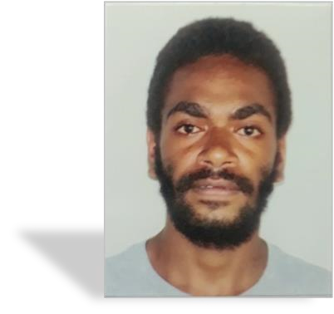

# EDUCATION

**Certificate of completion|** **The Bonavero Institute of Human Rights and UNESCO**

May 2021 – June 2021

**Year 14 science Certificate | LAB High School**

## FEBRUARY 2020 – NOVEMBER 2020

**Year 13 Certificate | LAB High School**

## FEBRUARY 2019 – NOVEMBER 2019

# EXPERIENCE

SCHOOL: SAINT JACQUES SCHOOL (SANTO)

POSITION: INTERN IN ADMINISTRATION

REFERENCE: LOLIA IMBERT-PRINCIPAL

# SKILLS

|  |  |  |
| --- | --- | --- |
| * Punctual * Motivated * Time management | | |
| * Headship * Oral & written communication * Computer Literacy * Good customer service |  |

|  |
| --- |
|  |
|  |

# LANGUAGE

* French
* English
* Bislama