**Curriculum Vitae**

Name: Lako Timaima Tosusu

Residential Address: Freshwater 2 Area, Port Vila

DOB: 19 February 1998

Age: 23 years

Island/ Province: Santo – Sanma

Email: [pn.tima67@gmail.com](mailto:pn.tima67@gmail.com)

Phone: 5381903/ 7792494

**Educational Background:**

|  |  |  |
| --- | --- | --- |
| **School** | **Year** | **Qualification** |
| Vanuatu Institute of Technology | 2021 | Business in Finance Accounting; Certification 4. Currently Studying. |
| Vanuatu Institute of Technology | 2020 | Business in Administration Services; Certificate 2. |
| USP | 2018-2019 | Foundation |
| Malapoa College | 2017 | SPFSC (Year 13) |
| Onesua Presbyterian College | 2015-2016 | VSSC (Year 12) |
| Onesua Presbyterian College | 2013-2014 | Year 10 Certificate |
| Vila East School | 2002-2012 | Preschool- Year 18 Certificate |

**Experiences:**

|  |  |  |
| --- | --- | --- |
| 2021 | Paton Memorial Church Youth Fellowship | Secretary |
| 2020 Feb - March | Department of Civil Status | Data Entry Volunteer |
| 2018 Dec – 2019 Sep | Department of Agriculture and Rural Development | Part-time receptionist |
| 2016 – Year 12 | Onesua Presbyterian College | Christian Fellowship Leader |
| 2015 | Australian High Commission | Helper (Cleaner) |
| 2014 | Carrie Shopping Center | Helper |

**Personal Skill:**

* Time Management
* Trust worthy
* Approachable
* Successful in carrying out tasks
* Honest and reliable
* Flexible in Excel and Microsoft
* Switch Board Operator
* Responding to Emails
* Appointment Scheduling

I declare that the following statements stated about me from this CV are true and valid.

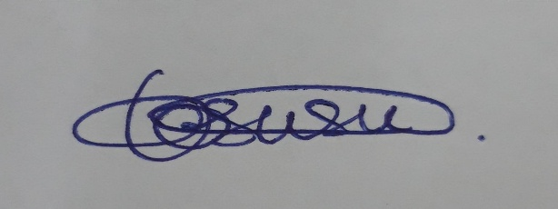Name: Lako Timaima Tosusu

Signature:

Date: 13th December 2021